BUGS V1.0.1

* Allies can move past enemies

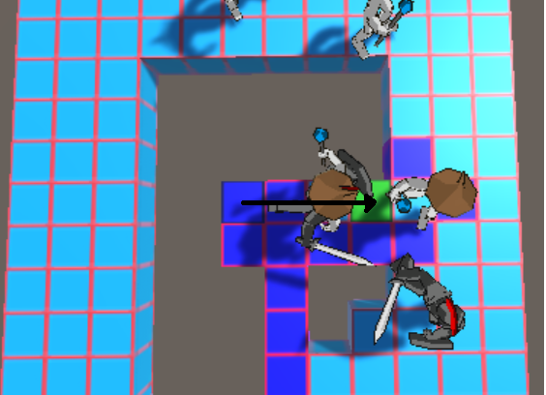

* Enemies will not move if there is a unit (ally or enemy) blocking the path between the attacker and defender

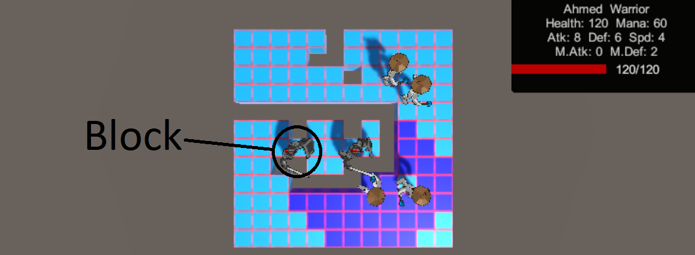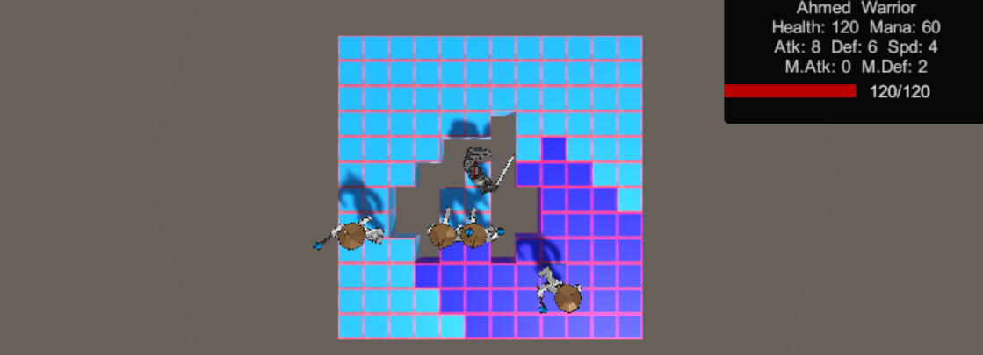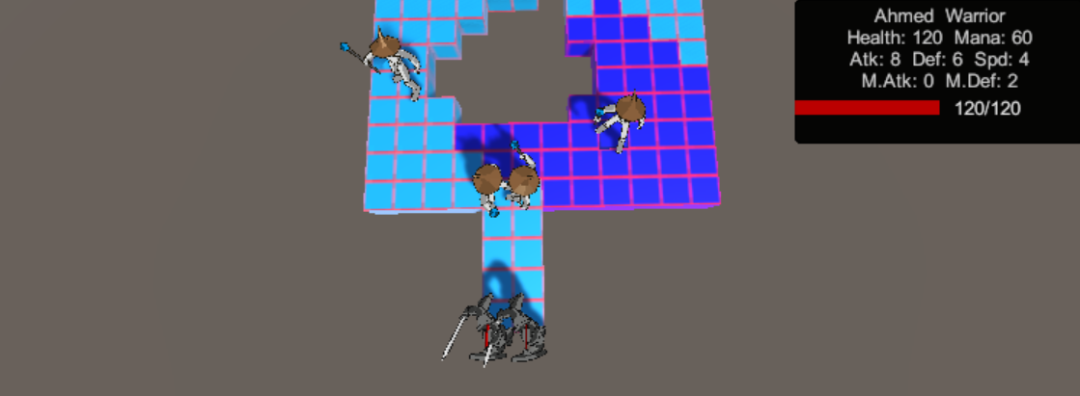

* Similar to the one above, enemies will find a different route if there is an enemy blocking the path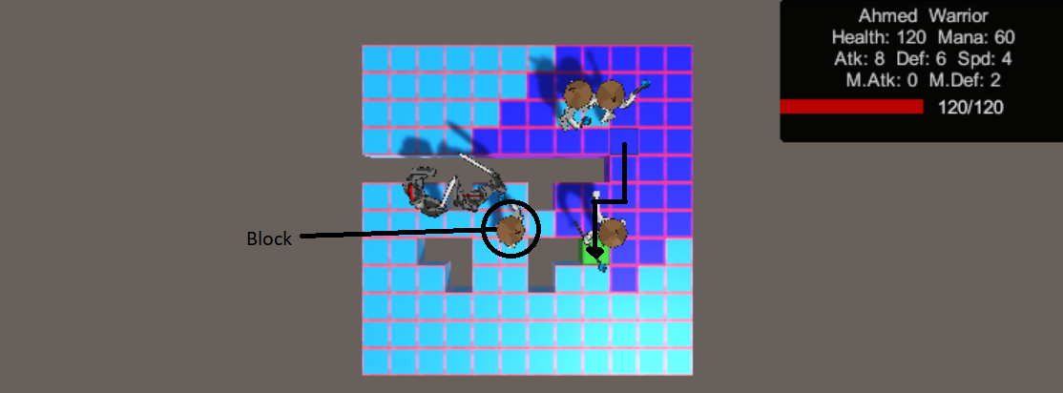

* Enemies can’t go past other enemies. They generally go around each other.

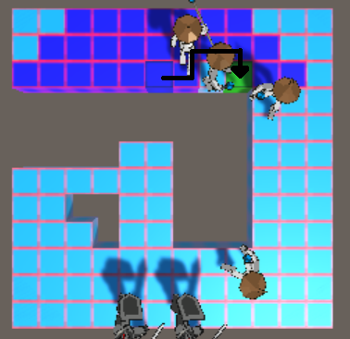

* Enemies will move toward ally units even if they are already dead

